**Project #1: California Housing Price Prediction**

**Question1: Load the data**:

* Read the “**housing.csv**” file from the folder into the program.
* Print first few rows of this data.
* Extract input (X) and output (Y) data from the dataset.

*Q#1 Code:*

import numpy as np

import pandas as pd

from matplotlib import pyplot as plt

*#1.1*

housing_data = pd.read_excel('/home/labsuser/Datasets/housing.xlsx')

*#1.2*

housing_data.head()

*#1.3*

X = housing_data.drop(columns=['median_house_value'],axis=1)

Y = housing_data['median_house_value']

*Screenshot:*

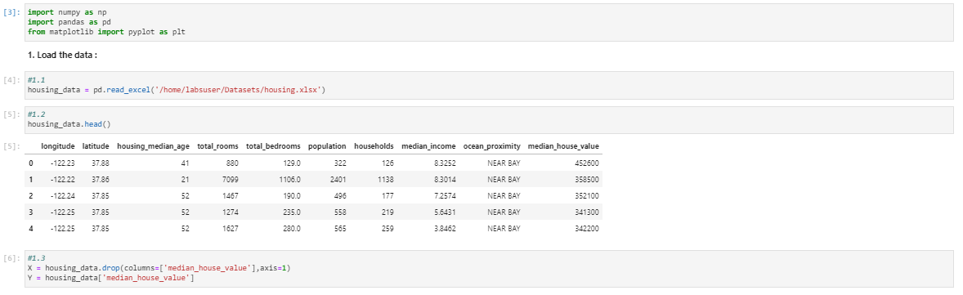

**Question2: Handle missing values** :

* Fill the missing values with the mean of the respective column.

*Q#2 Code:*

for i in X.columns:

if(X[i].hasnans):

print("Column", i, "-","has NANs",X[i].hasnans)

X[i].fillna(value=X[i].mean(), inplace=True)

print("NANs replaced with mean value in column", i)

if(Y.hasnans):

Y.fillna(value=Y.mean(), inplace=True)

*Screenshot:*

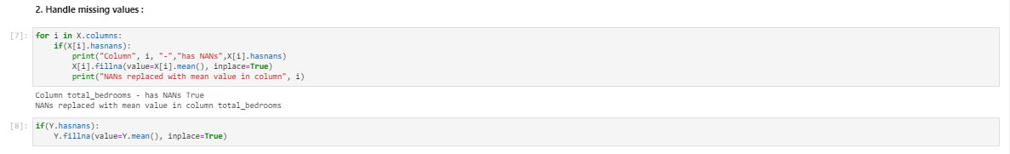

**Question3: Encode categorical data** :

* Convert categorical column in the dataset to numerical data.

*Q#3 Code:*

X['ocean_proximity'].unique()

X['ocean_proximity'].replace(to_replace=["NEAR BAY", "<1H OCEAN", "INLAND","NEAR OCEAN","ISLAND"], value=[1,2,3,4,5], inplace=True)

X['ocean_proximity'].unique()

*Screenshot:*

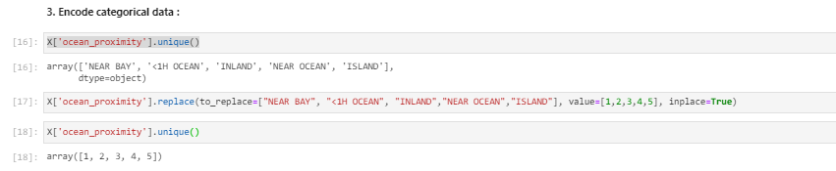

**Question4: Split the dataset** :

* Split the data into 80% training dataset and 20% test dataset.

*Q#4 Code:*

from sklearn.model_selection import train_test_split

x_train,x_test,y_train,y_test = train_test_split(X,Y, test_size=0.20)

print(x_train.shape)

print(y_train.shape)

print(x_test.shape)

print(y_test.shape)

*Screenshot:*

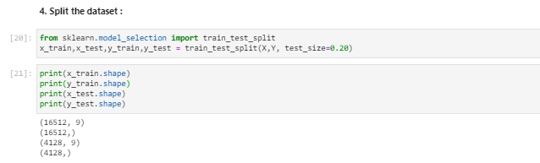

**Question5: Standardize data** :

* Standardize training and test datasets.

*Q#5 Code:*

from sklearn.preprocessing import StandardScaler

scaler = StandardScaler()

scaler.fit(x_train)

scaler.fit(x_test)

scaler.fit(pd.DataFrame(y_train))

scaler.fit(pd.DataFrame(y_test))

trans_x_train = scaler.transform(x_train)

trans_x_test = scaler.transform(x_test)

trans_y_train = scaler.transform(pd.DataFrame(y_train))

trans_y_test = scaler.transform(pd.DataFrame(y_test))

#housing_data.columns

trns_train_df = pd.concat([pd.DataFrame(trans_x_train, columns=['longitude', 'latitude', 'housing_median_age', 'total_rooms',

'total_bedrooms', 'population', 'households', 'median_income',

'ocean_proximity']), pd.DataFrame(trans_y_train, columns=['median_house_value'])], axis=1)

#trns_train_df.shape

trns_test_df = pd.concat([pd.DataFrame(trans_x_test, columns=['longitude', 'latitude', 'housing_median_age', 'total_rooms',

'total_bedrooms', 'population', 'households', 'median_income',

'ocean_proximity']), pd.DataFrame(trans_y_test, columns=['median_house_value'])], axis=1)

#trns_test_df.shape

*Screenshot:*

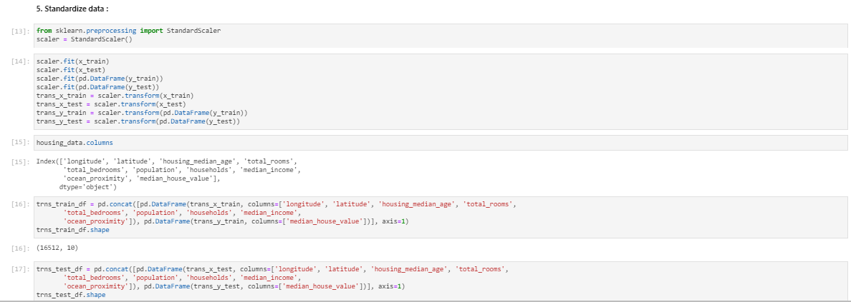

**Question6: Perform Linear Regression**:

* Perform Linear Regression on training data.
* Predict output for test dataset using the fitted model.
* Print root mean squared error (RMSE) from Linear Regression.

            [ HINT: Import **mean_squared_error** from **sklearn.metrics** ]

*Q#6 Code:*

*#6.1*

from sklearn.linear_model import LinearRegression

model = LinearRegression()

model.fit(trans_x_train,trans_y_train)

*#6.2*

pred_val = model.predict(trans_x_test)

new_df = pd.concat([trns_test_df, pd.DataFrame(pred_val, columns=['Predicted_Value'])],axis=1)

new_df['err_pctg'] = abs(new_df['median_house_value'] - new_df['Predicted_Value'])/new_df['median_house_value']

new_df.shape

*#6.3*

from sklearn.metrics import mean_squared_error

mean_squared_error(new_df['median_house_value'], new_df['Predicted_Value'])

*Screenshot:*

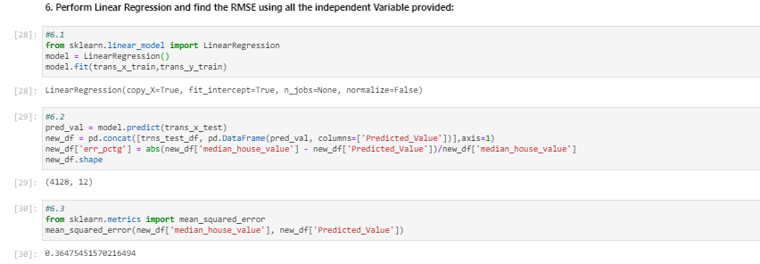

**Question7: Bonus exercise: Perform Linear Regression with one independent variable** :

* Extract just the median_income column from the independent variables (from **X_train** and **X_test**).
* Perform Linear Regression to predict housing values based on **median_income**.
* Predict output for test dataset using the fitted model.
* Plot the fitted model for training data as well as for test data to check if the fitted model satisfies the test data.

*Q#7 Code:*

*#7.1*

X1= x_train['median_income']

Y1= y_train

X2= x_test['median_income']

Y2= y_test

*#7.2*

new_model=LinearRegression()

new_model.fit(pd.DataFrame(X1),Y1)

*#7.3*

pred_val=new_model.predict(pd.DataFrame(X2))

new_df1 = pd.concat([X2.reset_index(),Y2.reset_index(),pd.DataFrame(pred_val, columns=['Pred_Value'])],axis=1)

new_df1.head()

new_df1['err_pctg'] = abs(new_df1['median_house_value'] - new_df1['Pred_Value'])/new_df1['median_house_value']

1-new_df1.err_pctg.mean()

*#7.4*

from matplotlib import pyplot as plt

plt.figure(figsize=(30,30))

plt.scatter(new_df1['median_house_value'], new_df1['Pred_Value'])

plt.xlabel('median_house_value')

plt.ylabel('Pred_Value')

plt.show()

*Screenshot:*

